Swedish LYS-rule classification
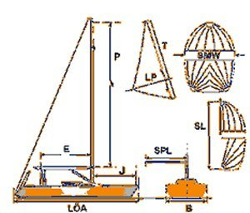
Abbreviation | value | Description
ID | SF60 | Identification code
Boat Type | Sheriff 600
LYS | 0.90 | LYS classification code
UTR | SG- | Indicates ordinary sail wardrobe consisting of Spinnaker and Genoa
LÖA | 6.22 m | Overall length, including everything
B | 2.30 m | Overall width, including everything
DEPL | 1.00 ton | Least allowable displacement
P | 6.80 m | Greatest allowable distance between the inner edge of the upper and lower mast maesuring points.
E | 2.70 m | Greatest allowable distance from the after-side of the mast to the inner edge of the booms measuring point.
T | 6.30 m | Greatest allowable length of forward jib leech
LP | 3.15 m | Greatest allowable distance perpendicular to the forward jib leech
J | 2.35 m | Horisontal distance from forward-edge of the mast to the fastening device of the forestay in the deck
SL | 6.20 m | Greatest allowable length of the standing leech of a spinnaker
SMW | 4.61 m | The greatest allowable width of the spinnaker
SPL | 2.56 m | Greatest allowable distance from the centerline of the forward-edge of the mast to the outermost point of the spinnaker pole when it is placed horisontally, is extended to its maximum and is perpendicular to the centreplane of the hull

